Experiment 8
Laplace Transform Analysis

Objective 1: Analysis of Laplace Transform of Continuous-Time Signals.
Code :
clc;
clear;
close all;
%% 8(i) Laplace Transform Analysis
% Requires Symbolic Math Toolbox
syms t s
x = exp(-2*t)*sin(3*t)*heaviside(t);
X = laplace(x,t,s);
disp('Laplace Transform X(s) =');
pretty(X);
omega = -20:0.05:20;
Xjw = double(subs(X,s,1j*omega));
figure;
plot(omega,abs(Xjw),'LineWidth',1.1);
grid on;
xlabel('\omega (rad/s)');
ylabel('|X(j\omega)|');
title('Magnitude of Laplace Transform on j\omega Axis');
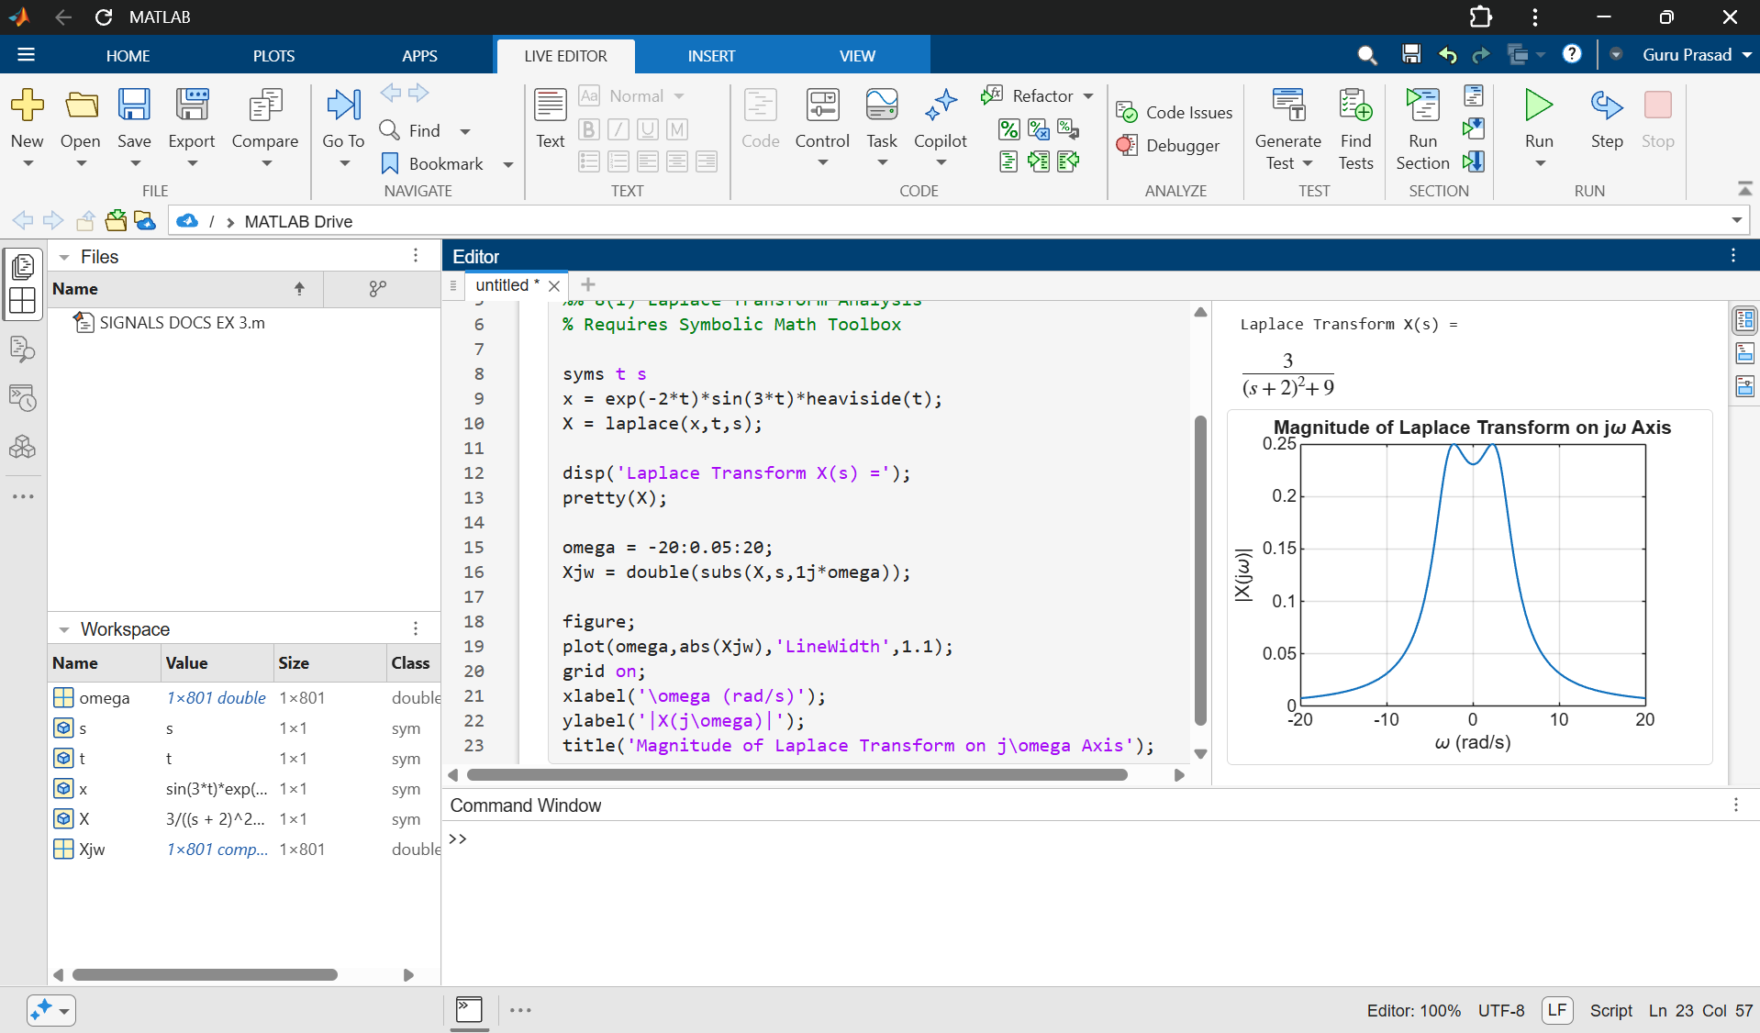

Objective 2: Inverse Laplace Transform and Signal Reconstruction
Code :
clc;
clear;
close all;
%% 8(ii) Inverse Laplace Transform
% Requires Symbolic Math Toolbox
syms s t
X = 1/((s+2)*(s+3));
x = ilaplace(X,s,t);
disp('Inverse Laplace Transform x(t) =');
pretty(x);
tt = 0:0.001:5;
xx = double(subs(x,t,tt));

figure;
plot(tt,xx,'LineWidth',1.2);
grid on;
xlabel('Time (s)');
ylabel('Amplitude');
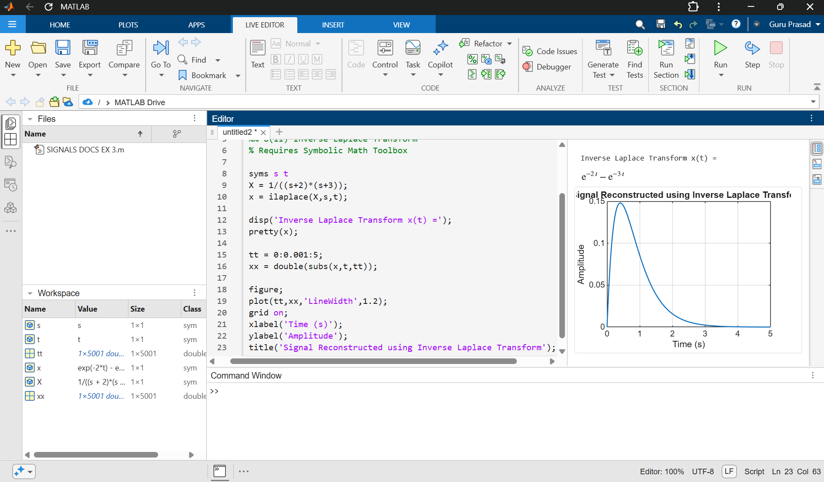
title('Signal Reconstructed using Inverse Laplace Transform');

Objective 3: Determination of Region of Convergence (ROC)
Code :
clc;
clear;
close all;
%% 8(iii) Region of Convergence (ROC)
poles = [-2 -4];
figure;
plot(real(poles),imag(poles),'rx','MarkerSize',12,...
'LineWidth',2);
hold on;
xline(-2,'--b','Re(s) = -2');
xline(-4,'--g','Re(s) = -4');
grid on;
xlabel('Real Axis');
ylabel('Imaginary Axis');
title('Pole Locations and ROC Boundaries');
legend('Poles','Location','best');
disp('Poles are at s = -2 and s = -4');
disp('Right-sided ROC: Re(s) > -2');
disp('Left-sided ROC: Re(s) < -4');
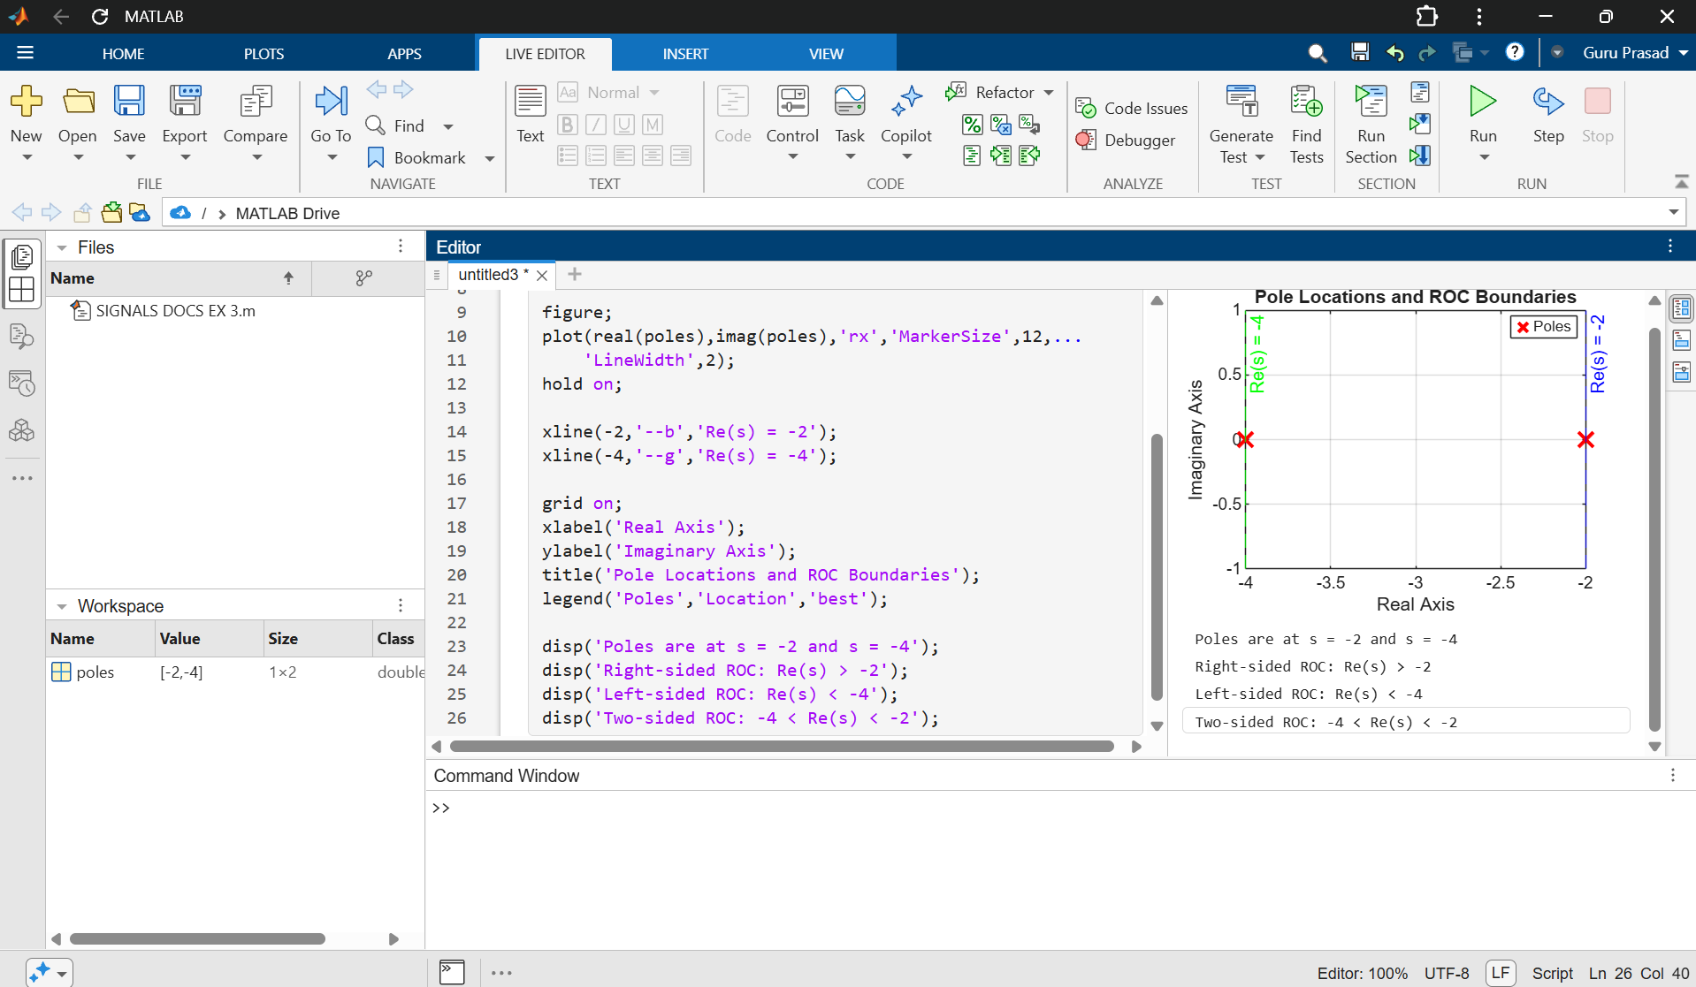
disp('Two-sided ROC: -4 < Re(s) < -2');

Objective 4: Analysis of System Stability Using Poles, Zeros and ROC
CODE :
clc;
clear;
close all;
%% 8(iv) System Stability Analysis
% Requires Control System Toolbox
num = [1];
den = [1 4 5];
sys = tf(num,den);
disp('Transfer Function:');
disp(sys);
disp('Poles:');
disp(pole(sys));
disp('Zeros:');
disp(zero(sys));
figure;
pzmap(sys);
grid on;
title('Pole-Zero Map');
t = 0:0.01:8;
figure;
impulse(sys,t);
grid on;
title('Impulse Response');
xlabel('Time (s)');
ylabel('h(t)');
figure;
step(sys,t);
grid on;
title('Step Response');
xlabel('Time (s)');
ylabel('y(t)');
p = pole(sys);
if all(real(p) < 0)
disp('The system is BIBO stable.');
else
disp('The system is not asymptotically stable.');
end

